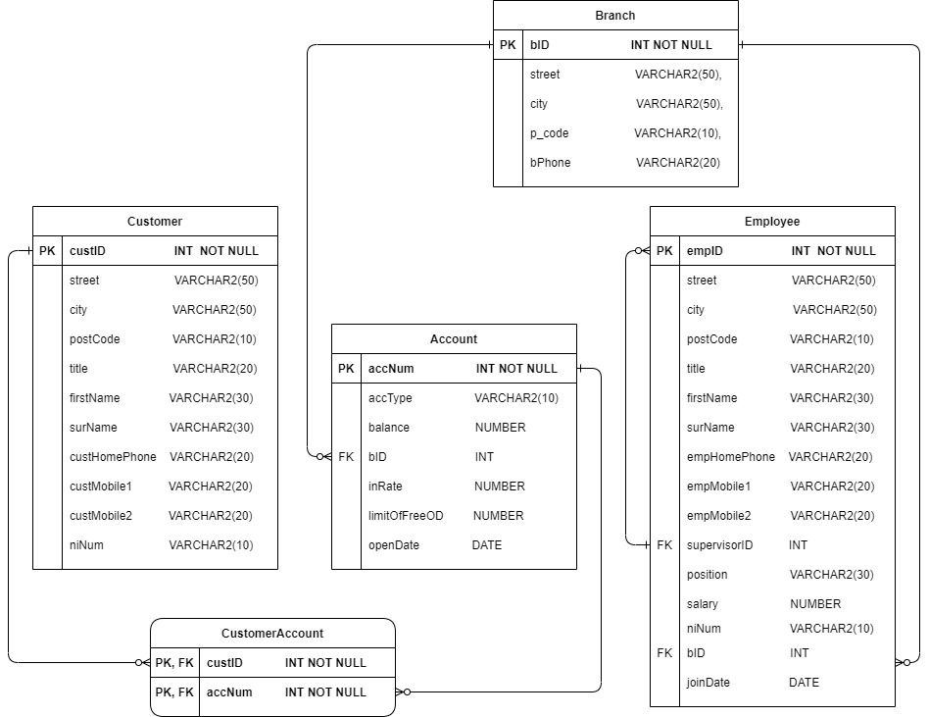

1. **DESIGN**

Database designing is critical to the successful implementation of a database management system that meets the data requirements of an entire system. I used the Entity-Relationship Diagram (E-R Diagram) above which I designed from the schema provided in the coursework for the Relational Database used for a bank. I used these and the questions provided in task 4 to design an Object-relational Database to better capture the relationships between attributes in the tables (ie, more closely related data information will be grouped together in a way that increases the semantics of the application) taking into account the number of steps it would have to go through when a query was implemented or called.

Structured types

I implemented Structured types to represent the data contained in each of the original tables in the relational database design laid out in the E-R Diagram in Task 1 – ‘Branch Type’, ‘Employee Type’, ‘Account Type’, ‘Customer Type’ and ‘Customer Account Type’. I then created Structured Types for the related key data stored in each of the tables and applied them as objects within the main structured types before making them into their own tables.

I created the user defined types of:

* **Name** Object Type - Containing Title (title), first name (FirstName), surname (SurName) and National Insurance Number (NiNum) attributes. As well as a Method to produce a concatenation of the name attributes title, firstName and SurName to (Full_Name)
* **Address** Object Type – Containing Attributes for Street(street), City (city) and postcode(postcode) Attributes. Also a Method to produce a concatenation of the address, street, city and postcode to (Full_Address).
* **People** Object Type - Made up of the two previous structure types of Name(obj_name) and address (obj_address) to the type of (kbs_people_Type).
* **Customer Phone Numbers** Object Type - Containing customer home phone number and an option for 2 customer mobile numbers. Any or all 3 of these values may be NULL. This object was designed to be a nested table within the Customer Table for ease when accessing the customer phone numbers or any query that required a query that linked between them.
* **Customer Type** Object type – Is a Subtype of the people object type, with added attributes for customer ID (custID) and the nested table of the customer phone numbers (cst_phone_nums) making the completed Customer structure type (kbs_CustomerType). This then became the completed ‘Customer Table’
* **Branch Type** Object Type – Consisting of a Branch ID (bID) set as the primary key set as unique and not null to make sure only one branch details exists for each branch. An object of the address type (obj_Branch_Address) and the branch phone number (bPhoneNum). This then became the completed ‘Branch Table’
* **Employee Phone Numbers**  Object type – Consisting of the employees home phone (empHomePhone), a first possible mobile number for the employee (EmpMobile1) and a second one (EmpMobile2). Unlike in the Customer phone numbers I didn’t create a nested table for the employee’ phone numbers, I made them as an object.
* **Job Type** Object Type – Containing two attributes of job title (position) and salary amount(salary).
* **Employee People type** Object Type – Is a subtype of People Type with the added attribute of a job object (obj_job).
* **Employee type** Object Type – Is a subtype of Employee People type with all the attribute inherited from there as well as the added Attributes of job type (obj_job), employee ID(empID) and the date an employee joined the bank (joinDate). Two references, one for the branch iD (bID_r) and the supervisor ID (supervisorID_r) referencing the empID from the same table, because the supervisor ID is the employee ID number of that supervisor. Lastly, I included a function to work out the end of year employee awards. This type is then used to compile the Employee Table and contains the method for question 4H for defining and allocating the end of year employee awards.
* **Account Financials Type** Object Type - Containing three attributes for account balance (balance), the interest rate for the account (inRate) and the limit of the overdraft available for the account (limitOfFreeOD).
* **Account Type** Object Type – Constructed of the object type from the account financials type (obj_accFinancials), and three further attributes. One attribute for the account number (AccNum), one for the account type (accType) and one for the date the account is opened (openDate). Then a reference attribute which is a pointer to the branch ID in the branch type (bID_r).
* **Customer Account Type** Object Type - is a reference type that consists of two reference attributes, one that points to the customer ID in the customer Type(custID_r). The other points to the Account number in the Account Type (AccNum_r)

Inheritance

The **customer table** inherits attributes from the ‘people type’ which consists of the address type object which have the attributes of [street, city and post code] and the name type object, with attributes of [title, firstName and surname].

The **employee table** inherits attributes from the ‘employee people type’ which in turn inherited it’s attributes from ‘people type’. it consists of the address type object which has attributes of [street, city and post code], the name type object with attributes of [title, firstName and surname] and the employee Phone type object with has the attribute [EmpHomePhone, EmpMobile1, EmpMobile2].

References

I used References within the Account and Employee Tables to work in a similar fashion to the foreign keys in the Relational Design. This allows the reference attribute bID_r in these tables to be a pointer to the information contained in the Branch Table for ease of calling data in the queries and linking the account table and employee tables to the appropriate bank branch.

I set a reference from supervisor ID (supervisorID_r) to the employee ID (empID) as the supervisor ID is just the Employee Id where the job position of that employee is in a supervisorial capacity.

The Customer Account Table is set as a reference table (customerAccount_ref_table) from the structured type of the customer Account Type (customerAccount_ref). The two attributes in the table are pointers. One column is a pointer to the customer type referenced by the matching of the CustID (custID_r) in reference attribute of custID in the Customer Type. The other is a pointer to the Account Type referenced by the Account Number (AccNum_r) to the referenced attribute AccNum in the Account type.

Methods

I included a **MEMBER METHOD** in the employee table to Answer Task 4H by calculating the number of people an employee supervises and their length of service. Then returning the employee award status each qualifying employee would receive. Whether that be gold, silver or bronze awards.

I also included **MEMBER METHOD** in the name type object and address type object to return the full name (title, firstName and surname) and the full address (street, city and postcode) respectively when called from within a query.

Constraints

The attribute ‘position’ in the ‘Employee table’ could only be defined as one of 5 different job titles. I therefore used the **CHECK** a constraint with the constraint name of ‘position_const’ to check that the data entered within this parameter fell within one of these categories of either 'Head', 'Manager', 'Project Leader', 'Accountant' or 'Cashier' to prevent bad data being introduced into the database and producing errors.

Similarly, in the ‘Account table’ the ‘Account Type’ (AccType) parameter can only be set as 'Current' or 'Savings' so I introduced a **CHECK** constraint there too with the constraint name of ‘accType_const’.

Branch table ID (bID), Customer table ID (custID) and the Account Number (AccNum) stored in the Account table are all set with the ‘**PRIMARY KEY** Constraint’ as well as the ‘**NOT NULL** Constraint’. By default a primary key has to be unique, this is implicit and therefore do not need to set the ‘**UNIQUE** constraint’ on these attributes.

Collections

Collections can be used when you have a multiple pieces of data attributed to a single attribute. You can use a **VARRAY** if you know at compile time how many items will be in the list. A **NESTED TABLE** can offer increased flexibility when dividing into sub-tables within the nested table collection and you can add infinite data as you don’t need to define the number of tuples you will be adding during the running of your programme.

I used a Nested Table within the customer type to store the phone numbers, home and mobile.

**DATABASE RATIONAL and ALTERNATIVES**

The re-designed database I implemented to replace the original relational database makes extensive use of object-relational features while still retaining the originally implemented semantics of the application.

There were a great number of design decisions I had to reflect on before deciding on my finished design. Here are some of the alternatives which I looked into before deciding on my finished design and the rational for the decisions reached.

I could have used objects of people type to create the tables for Customer and Employee rather than subtypes which I used to populate them as a subtype rather than an object. I decided to use the hierarchical approach for the base key contents and included the others as individual attributes typically used in relational databases and the object types used in Object Oriented database designs.

I wanted to design the person object to hold slightly different attributes for employee and customer tables yet similarly still inherited from the objects making up the structure Types for Name and Address.

I also contemplated putting the Branch as an object into the account Table only and not producing a Branch Table at all, as ultimately a Branch can only exist if it has accounts to link to it.

Instead of having separate addresses stored within the Address table and Customer tables, I could have had a completely separate address table which would be referenced by customer, employee and branch tables. Although this would have removed the need for duplicate data entry when a person was both a customer and an employee, it also removed the flexibility which I had decided on at the design stage to allow people to retain their maiden name after marriage for work purposes.

I contemplated making just one final finished Table called ‘Bank’ and each of the other tables being objects within the type bank. I decided the data split into different sub-tables linked by refences for the existing foreign keys would produce quicker results from the queries and dial back the level of complexity which would be involved in populating the entire database laid out as one table.

Due to the end of year employee awards are ‘end of year’ I considered making the length of service worked out against the last day of the current year, as opposed to worked out from SYSDATE or having a static method which took a user entered date to which the awards would be worked out against. But after consideration, I decided that using sysdate on the day of the awards was a more prudent approach than introducing potential errors from someone entering the wrong date or having the cut-off date on the 31st of December, when the actual awards themselves may be dated in November.

I thought of using a VARRAY to hold the 2 mobile numbers and use the varray to populate the nested table. This allows grouping in the Varray as well as the flexibility of these numbers in an unordered list within the nested table. I opted not to do this as felt the nested table already offered the structure I was looking to store the phone numbers and adding a varray would only be increasing complexity without increasing functionality.

I made job a separate object as an employee could change job position and salary, but their other details would remain consistent within the employeeType. JoinDate and empID would remain constant during their time of employment at the back. I was however going to put supervisorID within the job type as felt they were related fields, but again I decided it increased functionality to leave it in the main employee Type to allow for ease of refencing the supervisor to the employee.

1. See Attached Scripts:

* DBCreating.sql : Creating Types, Tables and implementing Methods as outlined in the design in Task 2.
* DBPopulating.sql :Containing all the data to populate the tables within the object

relational database.

1. See Attached Script:

* answersToTask4.sql : Containing all the queries outlined below to answer the questions in Task 4.

1. SELECT e.Obj_name.Full_Name() Full_Name

FROM kbs_employeeTable e

WHERE (UPPER(e.Obj_name.firstName) LIKE '%ST%')

AND (UPPER(e.obj_address.city) = 'EDINBURGH')

;



1. SELECT COUNT(a.accNum) Num_Of_Savings_Accounts ,b.biD, b.obj_Branch_Address.Full_Address()Full_Address

FROM kbs_branchTable b

LEFT JOIN kbs_AccountTable a

ON b.bId = a.bID_r.bId

AND UPPER(a.accType) = 'SAVINGS'

GROUP BY b.bID, b.obj_Branch_Address.Full_Address()

ORDER BY COUNT(a.accNum)DESC

;



1. SELECT a2.bID_r.bID, c.custID_r.obj_name.Full_Name() Full_Name , a2.obj_accFinancials.balance MAX_Account_balance

FROM ( SELECT a.bID_r.bID, MAX(a.obj_accFinancials.balance) max_balance

FROM kbs_AccountTable a

WHERE UPPER(a.accType) = 'SAVINGS'

GROUP BY a.bID_r.bID) a1, kbs_AccountTable a2, CustomerAccount_ref_table c

WHERE a1.max_balance = a2.obj_accFinancials.balance

AND a2.accNum = c.accNum_r.accNum

ORDER BY a2.bID_r.bID

;



1. SELECT e.bID_r.obj_Branch_Address.Full_Address() Address_Where_Employee_Works,

r.AccNum_r.bID_r.obj_Branch_Address.Full_Address() Address_Where_Account_Opened

FROM kbs_employeeTable e, kbs_customerTable c, customerAccount_ref_table r

WHERE UPPER(e.supervisorID_r.obj_job.position) = 'MANAGER'

AND e.obj_name.NiNum = c.obj_name.NiNum

AND c.CustID = r.custID_r.CustID

;



1. WITH jointCurrentTable AS(SELECT r.AccNum_r.bID_r.bID bId, r.custID_r.obj_name.Full_Name() Full_Name , r.AccNum_r.obj_accFinancials.limitOfFreeOD overdraft

FROM CustomerAccount_ref_table r

WHERE UPPER(r.accNum_r.accType) = 'CURRENT'

AND EXISTS

(SELECT 1

FROM CustomerAccount_ref_table r2

WHERE r.accNum_r = r2.accNum_r

AND r.custID_r != r2.custID_r))

SELECT jointCurrentTable.*

FROM jointCurrentTable,

(SELECT bId, MAX(overdraft) maxOd

FROM jointCurrentTable

GROUP BY bId ) maxODtable

WHERE jointCurrentTable.bId = maxODtable.Bid

AND jointCurrentTable.overdraft = maxODtable.maxOd

;



1. SELECT c.obj_name.Full_Name() Full_Name , t.CustMobile1, t.CustMobile2

FROM kbs_CustomerTable c, table(c.cust_phone_nums) t

WHERE t.custMobile2 IS NOT NULL AND t.custMobile1 IS NOT NULL

AND (t.custMobile2 LIKE '0750%' OR t.custMobile1 LIKE '0750%')

;



1. SELECT COUNT(e.empID)Supervised_By_Mrs_Smith_Under_Mr_Jones

FROM kbs_employeeTable e

WHERE UPPER(e.supervisorID_r.obj_name.title) = 'MRS'

AND UPPER(e.supervisorID_r.obj_name.surname) = 'SMITH'

AND UPPER(e.supervisorID_r.supervisorID_r.obj_name.title) = 'MR'

AND UPPER(e.supervisorID_r.supervisorID_r.obj_name.surName) = 'JONES'

;



1. SELECT k.Obj_name.Full_Name()Full_Name, k.employee_awards() Employee_Awards

FROM kbs_employeeTable k

WHERE k.employee_awards() IS NOT NULL

;



1. General disadvantages of object-relational Databases compared to a relational database include Ad-hoc querying compromises encapsulation, locking at object-level impacts performance and because of the hierarchical approach with supertypes and subtypes from the included objects and inheritance it means complexity is increased. One of the main disadvantages of my design is that because bank employees can also be customers, the current design requires that their details have to be entered twice. Equally if the details require to be amended this also would need to be done twice, once in employee and once in customer tables. For example If the employee, who also happens to be a customer at another branch, moved house or change their name currently it would need to be updated in both Tables. Although this was a deliberate design decision, which I initially implemented due to try to cater for the fact that some people after marriage remain using their maiden name for work capacities and use their married name for personal use. With reflection, I think a central table of addresses, names and contacts would be preferable. Referencing one address entry from both the Customer and Employee Tables would increase the functionality of the database and reduce a potentially dangerous part to introduce errors into the system.

Object-relational databases provide enriched modelling capabilities. Fully supporting a schema which can be extremely flexible for evolution and extendibility. In my bank schema for instance I could very easily add more attributes and cascade them down to existing structured tables and types with no problems. Referencing data from other tables means improved performance in speed and functionality in the database and the using related attributes in a single object makes it quicker to call them from queries.

1. See Attached Scripts:

* droppingTypesTables.sql : Dropping all types and Tables created in Task 3.